Environmental Modeling for Water Resource Assessment of Typhoon Haiyan-hit Coastal Watersheds in the Philippines
E.C. Herrera*¹⁾, J.B.L. Dumalag²⁾ and A.C. Blanco³⁾
¹⁾ Institute of Civil Engineering, University of the Philippines-Diliman, Quezon City
^{2),3)} Department of Geodetic Engineering, University of the Philippines-Diliman, Quezon City
* eugene.herrera@coe.upd.edu.ph
Keywords: ArcSWAT modeling, risk/vulnerability assessment, climate change
Introduction
A thorough knowledge of hydrology is a requirement for the effective management of environmental systems. Watersheds provide the fundamental ecological management units, and water serves as the medium for the transport of environmental loads and the link that drives the interaction among various system processes. For the effective protection and management of ecosystem services therefore, understanding of the hydrological pathways and numerous mechanisms that drive interactions within terrestrial ecosystems is crucial (Conaghan et al., 2010). Physical understanding of the interactions between hydrology, climate, and land use change is important for understanding and perhaps predicting the potential hydrological consequences of existing land use practices and climate trends (Li et al., 2007). There is a conviction that recent regional changes in temperature have had discernable impacts on physical and biological systems (IPCC, 2007). Recent studies show that climate change has altered water flows and resources in river basins also have enumerated the various consequences of urbanization and climate change on surface water quantity and quality: “flashier” hydrographs; unstable channel morphology; extinction of small streams in river networks; reduction in base flow contribution; increase in suspended solids; elevated nutrient and contaminant concentration; and reduction in biotic diversity.
In order to account for the natural heterogeneity within watersheds, limited spatial and temporal data sets, and influence of anthropogenic activities, hydrologic simulation models coupled with remote sensing techniques and geographic information system are employed for watershed management as decision-support tools. Distributed hydrologic models can assist decision-makers in dealing with ecosystem problems by providing systematic and consistent information on water availability, water quality and impact of human activities on hydrological regimes (Yang et al., 2007).
In November 8, 2013, the municipalities surrounding San Pedro Bay and Leyte Gulf area in Region 8, Philippines suffered tremendously by the onslaught of typhoon Haiyan, the strongest landfalling tropical cyclone on record. Among the more critical natural resource affected in the area is inland water. For risk and vulnerability assessment, development and land-use planning, disaster risk reduction, and climate change adaptation assessment, both quantitative and qualitative inventory of water resources has to be done with environmental services and climate change resiliency aspects being considered in the process. On this rationale, this study was conducted to investigate the influence of topography, land use, soil and climate condition on the hydrology of the watersheds affected by the onslaught of Typhoon Haiyan. It aims to clarify in particular: (1) baseline information on basin hydrology of the coastal basins, that includes water balance among others; (2) dependable water resources in the area; (3) impacts of land use change on the hydrological response of the watersheds (hindcasting and projection) and; (4) hydrological response to projected extreme weather conditions.
Material and Methods
Field measurements were conducted to capture seasonal/annual variations of environmental variables affecting watershed hydrologic conditions. A watershed scale, continuous, long-term, distributed numerical model, (Soil and Water Assessment Tool, Neitsch et al., 2002) was used to assess the hydrologic response of the coastal watersheds under various environmental conditions. The assessment includes delineation of the watersheds, quantification of water discharges and storages for different land covers as well as the utilization of water resource for a variety of purposes. It also includes the assessment of climate change scenarios in so far as water resource is concerned. Hydrologic analysis for reliability assessment of flows was conducted to determination dependable flows using flow duration technique. This analysis determines the percentage chance of exceedance of specific discharge/recharge rates. With outputs from hydrologic modelling and statistical analysis, the dependable river discharge and groundwater recharge rates were compared with the computed water demands of the population per basin. Scenario simulations incorporating projections in both population water demand, and land cover and/or meteorological conditions were also done, to assess inland water resource sustainability and resiliency, respectively.
Results and Conclusions
Table 1 below summarizes the annual average water balance discharge values for each of the six largest basins of the study area. These figures show the distribution of the basin precipitation into the different components of the basin's water balance, i.e. evapotranspiration, surface runoff, lateral soil discharge and percolation expressed in percentage of annual average discharge. Based from a 35 year hydrologic simulation (1979-2014), the distribution of water balance components represent annual average values. Fractions of the surface runoff, lateral soil discharge and percolated water constitute the basin's total river discharge. The percolation component on the other hand, more or less represent the groundwater recharge rates. Effectively, the estimated annual average river discharge and ground water recharge rates represent the sustainable rates water resource use. Thus, a picture of sustainable water use rates.
Figure 1 indicates the 95 % percent chance of exceedance of specific discharges relative to the rest of the discharges in the record of analysis. Low flows have relatively greater chance of exceedance than high flows, greater level of reliability therefore for water resource use. Domestic water resource development seemed most ideal for Higasaan River and Golden River basins with significant river discharge rates (>16 m³/s) having 95% reliability. It can also be observed that Golden River (9.56 m³/s) and Higasaan River (7.735 m³/s) basins have the largest recharge rates, with their rates significantly larger than those of the four other basins. It should be noted that these groundwater recharge rates are slightly smaller than the percolation rates primarily because portions of the infiltrated water contribute to vegetal transpiration before further percolation.
Figure 2 demonstrate the water balance estimates (left) and annual accumulated river discharge (right) for one of the watersheds of the study area, Abuyog-Higasaan river basin, under three climate change scenario projections. It can be seen that there is a general increase in total annual surface run-off and percolate volume of these basins due to the projected increase in precipitation during the wet season. Also, during the months of March to May, the months which are projected to receive a decrease in precipitation, river discharges significantly decreased. This correspondingly are foreseen to have significant implications on the reliability of the water resources in the area for supply development.
Scenario runs were also conducted to assess the effect of either changing land covers and/or meteorological input in the study area. This procedure basically provides information on the level of resilience the watersheds have with respect to changes in either land cover and/or meteorological input of the basin. Simulations runs (1979-2013) for one of the watersheds of the study area, the Abuyog – Higasaan river basin, are shown in Figure 3 wherein two different land covers (2000 and 2015) were compared for initial resilience analysis. It can be observed that the fraction of water that evaporates and becomes surface runoff are virtually the same for both simulations. Indicating, no significant effect(s) on these water balance components for the change in land cover and with the same meteorological input. However, the amount of percolation and lateral soil discharge demonstrated a slight change, with around one (1%) percent of the total volume of water transformed from percolation to lateral soil discharge component (equivalent to about 0.5 m³/s in discharge). This can be interpreted as having lesser volume of water percolating to contribute to the groundwater due to larger expanse of impermeable surface of the watershed brought about by urban and/or agricultural development.
With the use of a calibrated hydrologic model, baseline, hindcasting and forecasting scenario simulations were accomplished to assess the status, reliability, sustainability and resiliency of the inland water resources of typhoon Haiyan-hit coastal watersheds in the country, providing valuable information for water resource planning, development and risk/vulnerability assessment.
References
Conaghan, K. (2010), Assessing the hydrological implications of land use change for the upper Nuese River Basin. A Master Thesis on Environmental Management in Nicholas School of the Environment of Duke University, Durham, North Carolina, 59 pp.
IPCC (2007), Climate change 2007: synthesis report. Contribution of working groups I, II and III to the Fourth Assessment Report of the Intergovernmental Panel on Climate Change (Core writing team, Pachauri, P.K and Reisinger, A.), IPCC, Geneva.
Neitsch, S.L., J.G. Arnold, J.R. Kiniry, J.R. Williams & K.W. King (2002), SWAT Manual. USDA, Agricultural Research Service and Blackland Research Center, Texas A&M University, USA.
Li K.Y., M.T. Coe, & N. Ramankutty (2005), Investigation of hydrological variability in West Africa using land surface models. Journal of Climate, 18, 3173–3188.
Yang, J., P. Reichert, K.C. Abbaspour & H. Yang (2007), Hydrological modeling of the Chaohe basin in China: statistical model formulation and Bayesian inference. Journal of Hydrology, 340, 167-182.
Table 1 35-year average simulated water balance of the six largest watershed in the study area.
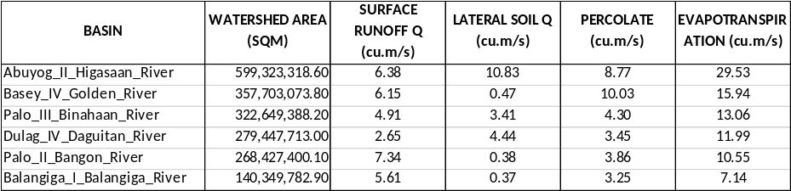
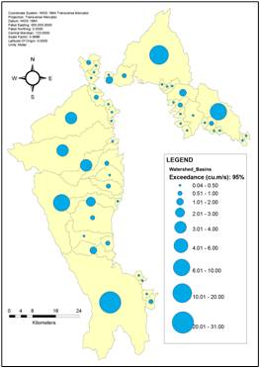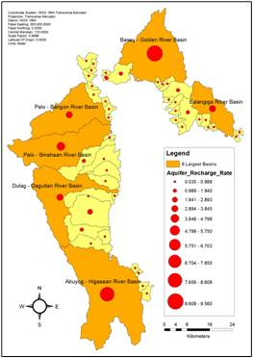
Figure 1 95% reliable river flows (left) and 35-year average groundwater recharge rates (right) in the study area.
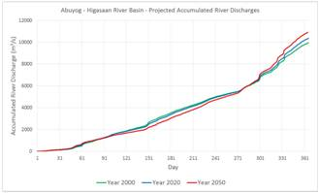
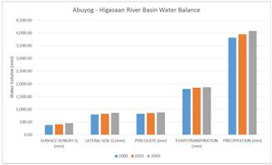

Figure 2 Water balance estimates (left) and annual accumulated river discharge (right) of Abuyog-Higasaan river basin under three climate change scenario projections.
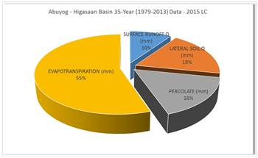
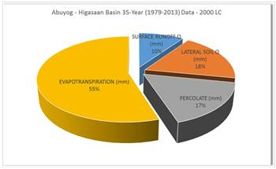

Figure 3 Water balance comparison between year 2000 (left) and year 2015 (right) land cover of Abuyog-Higasaan river basin.

